WINNER DRAFT

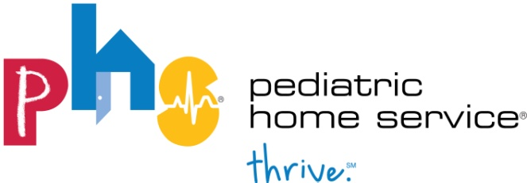

[INSERT COPY LOGO]

Katlyn Bourget [INSERT CONTACT NAME]
Sr. Digital & PR Specialist at PHS [INSERT CONTACT TITLE]
651-789-0937 [INSERT CONTACT INFO]
kjbourget@pediatrichomeservice.com

JUNE XX, 2019

[COMPANY NAME] named 2019 [INSERT CATEGORY “Top xxx”]
PHS Top Spots features Minnesota’s best places for families with special needs

St. Paul, Minn. – PHS Top Spots provides an annual resource for families of children with special needs to find the best spots in Minnesota that are set up to accommodate their needs, and [INSERT COMPANY NAME] was named the best spot for special needs families in [INSERT CATEGORY WON “top xxx”].

[“INSERT COMPANY QUOTE”]

The 2019 PHS Top Spots list was compiled through an online survey answered by families of children with medical complexities. The special needs community voted on nominated businesses and organizations in 12 categories, ranging from play spaces to support organizations across Minnesota. The third annual Minnesota resource was compiled by PHS with the goal to be an annual, statewide guide. New this year, Wisconsin families had the chance to vote for their top spots, with the goal to collect information to for a future Wisconsin PHS Top Spots guide.

“We are focused on ensuring children with medical complexities thrive at home,” said Cameo Zehnder, CEO of PHS. “Whether that means meeting their physical needs or their emotional needs, we want to support and provide resources that allow our patients to feel empowered to get out of their homes and live and enjoy life and that’s why PHS Top Spots was created. Zehnder added, “As we expanded into the full state of Wisconsin last year, we wanted to be able to provide our community and patient base in that region with the same resources. We want all people with special needs to have the opportunity to thrive at home and out in the community with this annual go-to list.”

Families can find the PHS Top Spots list at [INSERT COMPANY LOCATION IF HARD COPIES AVAILABLE FOR PICK UP] or via digital download at PHSTopSpots.com.

[INSERT YOUR COMPANY BOILERPLATE]

About Pediatric Home Service
Based in St. Paul, Minn., with an office location in Pewaukee, Wisc., Pediatric Home Service is an independent pediatric home care company that helps children with medical complexities and technology dependencies live safely and successfully where they're most comfortable, at home with their families, rather than in a hospital. Pediatric Home Service has been partnering with health care professionals and family caregivers for nearly three decades to deliver compassionate, specialized, high-quality care to children with special medical needs.

# # #

