Dear Valued Patient or Caregiver,
PHS has been informed about a Voluntary Medical Device Recall from Resmed for specific lot(s) of their AirFit F20 Non Magnetic Full Face Mask. In some lot(s) there is magnetic frame placed in the system package making the mask unusable. To date there have been no adverse effects reported.

A review of our records indicates that you may have received the affected product. Please refer to the table below to see if your product is on the list.
Product Name | Product Number |  | Lot Number | UDI
AirFit F20 NM (Medium) | 64029 | 1771288 |  | 619498642090
AirFit F20 NM (Medium) | 64029 | 1771295 |  | 619498642090

Please take these steps if you have affected product:
- Review your current inventory to see if you have affected product. Then scan the QR code and find Appendix B for instructions on identifying affected masks.
- If you have affected masks contact Resmed Customer Support directly at 1 (800) 424-9737. They will walk you through returning the recalled product and getting a free replacement.
- If you have no affected masks, no further action is needed.
If you have any questions please contact your local branch. To access the recall notice, scan the QR code.
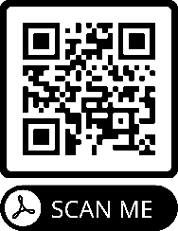
Your safety is important to us. Thank you for your attention to this matter.

Sincerely,
Samatha Hoy,
National Product Safety Manager

