2/25/2025

Dear Valued Patient or Caregiver,
We wanted to inform you that Smiths Medical has notified PHS of an Urgent Product Recall regarding BCI Airway Adapters that are supplied individually and/or in certain kits.
As stated in the Urgent Product Recall from the Manufacturer: “Investigation determined that the weld between the mating parts may not meet specifications.” As a result, Airway Adapters could break during use. If this happens it could cause inaccurate readings, disrupt ventilation, and in severe cases, lead to difficulty breathing and/or death. Smiths Medical reports there have been two reported product complaints related to this issue, but no serious injury or death has occurred as a result.
A review of our records indicates that you may have received products included in the attached Product Recall. See pages 2-4 to confirm if your product is part of this recall.
Affected Product Number | Affected Product Name | UDI
WW1100 | Airway Adapter, Straight | 35019517062667
WW8214 | Kit, Patient Attachment | 30610586038444

Please follow these steps if you have affected product(s):
- Inspect product for lot number and if product is listed in the recall check the correct assembly of the product on page 1 of the recall notice in Figure 1 and Figure 2.
- Discard any affected product immediately but record the item ID and Lot number.
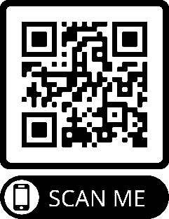
- Contact PHS for a replacement. Be prepared to share your item and lot number.
Scan the QR code to access the recall and to confirm your product is on the list. Your safety is important to us. Thank you for your attention to this matter. Please contact your local branch with any questions.

Sincerely,
Sam Hoy, National Product Safety Manager

