7/23/2025

Dear Valued Patient or Caregiver,
McKesson has notified PHS of an Urgent Field Safety Notice regarding specific lots of the SPUR Resuscitator variants. This recall was issued because, Ambu received five reports that the SPUR II device may have a blocked manometer port, causing the manometer to not function properly.
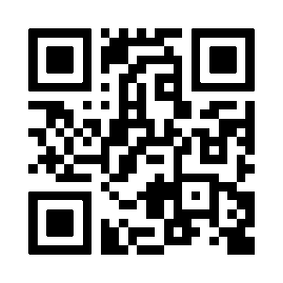
A review of our records indicates that you may have received the affected product. Please review the first page of the safety notice by scanning the QR code to see if you have affected product.
- Immediately discard affected products.
- Call PHS to receive a replacement item

Your safety is important to us. Thank you for your attention to this matter.

Sincerely,
Samatha Hoy,
National Product Safety Manager

