12/31/2025

Dear Valued Patient or Caregiver,
We wanted to inform you that Baxter Healthcare Corporation has notified PHS of a voluntary product recall for a certain lot of the Sterile Water 250-ml bottles. The recall was issued because small particles may be present in the solution.
As stated in the product notice, “the the sterile water solution may contain particulate matte.” If the particles are noticed before use, treatment may be delayed while a new bottle is obtained, and no harm is expected. If the particles are not noticed and the solution is used, Baxter indicates the particles would likely be washed away during the irrigation process. At this time, there have been no reports of patient harm or injury related to this issue.
A review of our records indicates that you may have received products included in this recall. Identifying item information can by found below.
Product Code | Product Description | Lot Number | Expiry Date | NDC
2F7112 | Sterile Water for Irrigation | G171359 | 05/31/2027 | 0338-0004-02

Please follow these steps if you have affected product(s):
- Immediately inspect product to see if your product matches those listed above and discard the product.
- If you have affected product, please contact PHS for a replacement.

You can access the full recall by scanning the QR code below.
Your safety is important to us. Thank you for your attention to this matter.
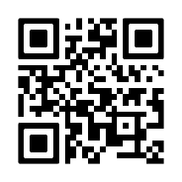
Sincerely,
Samatha Hoy
National Product Safety Manager

