1/14/2026

Dear Valued Patient or Caregiver,
We are writing to inform you that Cardinal Health at-Home has notified PHS of a voluntary Medical Device Withdrawal involving specific production batches of Dyranex skin products. This notice is being issued because a manufacturing process issue was identified in certain batches.

As stated in the Product Notice: “These batches were produced outside of validated batch size ranges, even though all products were manufactured using the correct formulas, approved raw materials, and proper formulation ratios.”

There is no patient harm, no known adverse effects, and no safety risk associated with these products. The products can continue to be used safely.
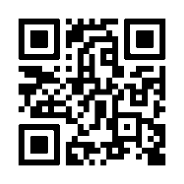
A review of our records indicates that you may have received products included in this voluntary withdrawal. You can identify affected products by scanning the QR code.

If you have affected product follow these steps:
- Check your product to see if it matches the items listed when you scan the QR code.
- If your product is affected, you may:
  - Continue using the product, or
  - Contact PHS to request a replacement.

Your safety is important to us. Thank you for your attention to this matter.

Sincerely,
Samatha Hoy
National Product Safety Manager

