2/24/2026

Dear Valued Patient or Caregiver,
We wanted to inform you that McKesson Medical-Surgical Inc. (MMS) has notified PHS of an Urgent Product Recall regarding MediHoney Wound & Burn products.

As stated in the Product Notice: “This notice has been issued because packaging failures were identified which could lead to a breach in the sterile barrier.” The affected product first shipped on August 5, 2020.

A review of our records indicates that you may have received products included in the attached Product Recall and listed below.
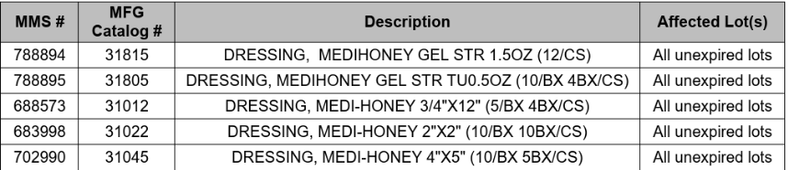
Please follow these steps if you have affected product(s):
- Immediately discard any product matching the affected items above.
- If you have affected product, please contact PHS to help identify a replacement
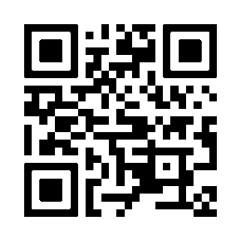
You can view the entire recall document by scanning the QR code.
Your safety is important to us. Thank you for your attention to this matter.

Sincerely,
Samatha Hoy
National Product Safety Manager

