April 7, 2026
Dear Valued Patient or Caregiver,
We are writing to inform you of a product recall issued by Mckesson that may regarding two specific lots of their Matisol.
The manufacturer has issued a recall for specific lots of their Matisol, due to complaints of the butyrate tubing cracking during actuation.
The manufacturer has reported no known risk or adverse harm, as the product is unusable if affected.
Product Information

MMS # | NDC # | Description | Affected Lot(s) | Exp. Date
384949 | 00496052348 | Matisol, STR TIP VL 2/3 CC (48/BX) | 24144B  24161B | 9/30/2059  9/30/2029

What You Should Do
If you have product that match the information above:
- Please do not use the product.
- Discard the vial if it matches the affected lot numbers.
- Contact Pediatric Home Service at 800-225-7477 so we can arrange replacement supplies.

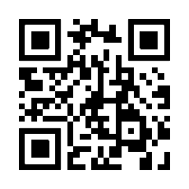
We apologize for any inconvenience this notice may cause and appreciate your attention to this matter. The safety of the children and families we serve remains our highest priority.
You can view the entire recall document by scanning the QR code.
Your safety is important to us. Thank you for your attention to this matter.
Sincerely,
Samatha Hoy
National Product Safety Manager
Pediatric Home Service

