04/22/2026
Dear Valued Patient or Caregiver,
We are writing to inform you of a product recall issued by Medline regarding specific lots of their 0.9% Sodium Chloride Irrigation USP, Sterile Water for Irrigation USP, and Saline Flush Syringes.
This recall was originally issued in November 2023 and has recently been updated to include additional affected products. These items are commonly included in kits used for flushing and irrigation.
The manufacturer issued this recall due to the potential for a lack of sterility, which could result in the solution being non-sterile. At this time, no serious adverse health effects have been reported due to this issue.
Product Information
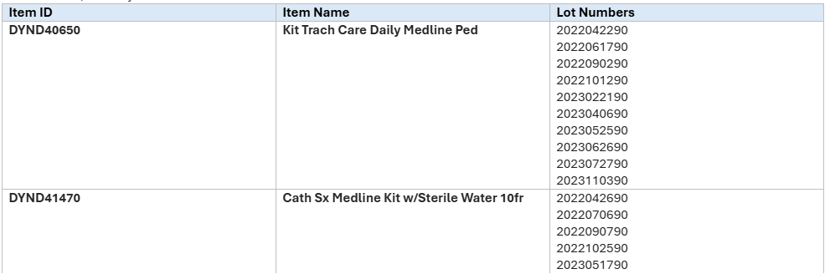
What You Should Do
If you have product that matches the information above:
- Immediately Discard any product that matches the affected lot numbers
- Contact Pediatric Home Service at 800-225-7477 for a replacement.
To view the entire safety recall, you can scan the QR code below. Your safety is important to us. Thank you for your prompt attention to this matter.
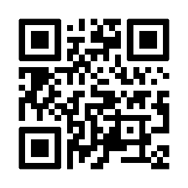
Sincerely,
Samantha Hoy
National Product Safety Manager
Pediatric Home Service

