Dear Valued Patient or Caregiver,
We wanted to inform you that McKesson Medical-Surgical Inc. (MMS) and Trividia have notified PHS of an updated Labeling Correction Notice for their TRUE METRIX Blood Glucose Monitoring Systems. This is not a recall, and the device itself is safe to continue using.
In February 2026, we previously notified families about updated instructions related to the E-5 error code that may appear on TRUE METRIX blood glucose meters. Since that time, the manufacturer, Trividia Health, has continued updating product instructions and is currently developing a software update for these meters. The software update is not yet available. Once available, families will be notified and Trividia will begin a meter upgrade program.
Our records indicate you may have received one of the affected products listed below.
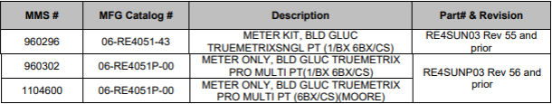
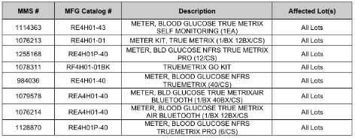
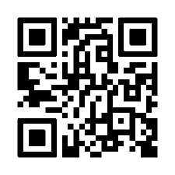
Please note: There are no product defects and no action is required from you at this time.
For more information on the list of co-brand partners, customer notices, and updated TRUE METRIX owner’s booklets, scan the QR code below.
Your safety is important to us. Thank you for your attention to this matter.
Sincerely,
Samatha Hoy
National Product Safety Manager

