05/28/2026
Dear Patient or Caregiver,
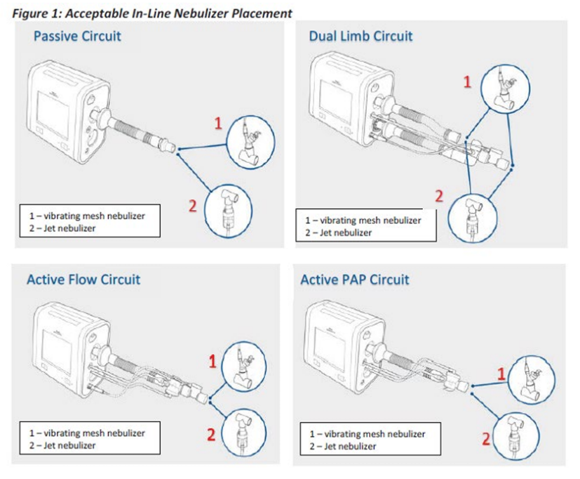
We are reaching out with an update regarding Philips Trilogy Evo devices. Philips has shared additional information related to specific alarm functions and revised guidance if using a non-pneumatic nebulizer with Trilogy Evo ventilators. The devices remain safe to use as directed by your care team. Philips is preparing software updates intended to improve performance and functionality for certain features within the system and released an updated User Manual addendum.
Philips has also provided revised guidance regarding non-pneumatic nebulizer use with Trilogy Evo ventilators. Non-pneumatic nebulizers may continue to be used when placed correctly within the circuit, following the instructions and guidance provided by your Respiratory Therapy care team. Please review the nebulizer placement guidance to the right for details.
As previously communicated, the device remains safe to use. The software update will address previously communicated issues and is intended to reduce inappropriate alarm notifications. Again, this does not change the current guidance to continue therapy as directed by your care team. For more details, please scan the QR code below.

We are actively monitoring the information and updates provided by Philips and will work with families to coordinate any recommended updates as they become available and appropriate.
For additional information, please scan the QR code below to review the Philips Field Safety Notice and updated User Manual addendum. If you have questions, please contact your local branch office.

Sincerely,
Samantha Hoy
National Product Safety Manager

