07/03/2026
Dear Valued Patient or Caregiver,
We are writing to inform you of an Urgent Medical Device Correction notice issued by ResMed regarding certain Astral 100 and Astral 150 ventilators manufactured before October 2024.
An internal electrical part inside some Astral ventilators may develop a leak over time. If this happens, the ventilator may stop delivering therapy and trigger a high-priority alarm. This is called a fail-safe mode.
This issue has been reported in fewer than 0.1% of all Astral ventilators — 5 units total worldwide. All affected patients recovered following intervention.
For patients that cannot breathe without the assistance of a ventilator, there is a risk of respiratory compromise if an alternate means of ventilation is not promptly provided. A review of our records indicates that you may have received an affected device
What You Should Do
ResMed has issued this notice out of an abundance of caution. Because this issue has affected fewer than 0.1% of devices worldwide, repairs are being scheduled based on clinical need. We will keep you informed as next steps become available for your device.
Please continue using your ventilator as directed by your care team. Do not stop using your ventilator unless your treating physician specifically instructs you to.
We also encourage you to:
- Review your Astral User Guide including ResMed’s recommendations related to monitoring, emergency preparedness, caregiver training, and availability of backup ventilation equipment.
- Confirm that your backup ventilator or alternative ventilation equipment is available, functional, and ready to use.
- If you are unsure how to respond to an alarm, review your emergency preparedness plan with your care team.
Contact your local PHS office with any questions about this notice, your device, your emergency preparedness plan, or backup equipment. Your RT case manager can help address your concerns.
What PHS Is Doing
PHS is following all guidance from ResMed. Due to a current shortage of replacement parts, not all ventilators can be corrected immediately. We are working with ResMed to repair the affected units, prioritizing patients based on ResMed’s clinical risk framework. We will reach out with further information as it becomes available.
Thank you for your prompt attention to this matter.
Sincerely,
Samantha Hoy
National Product Safety Manager
Pediatric Home Service

Resources to review

ResMed Recall Letter
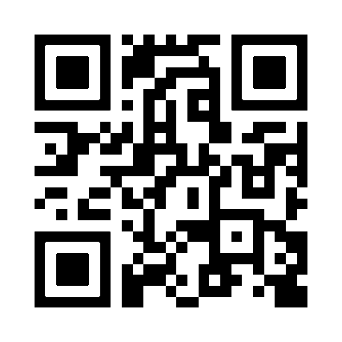

Astral User Guide
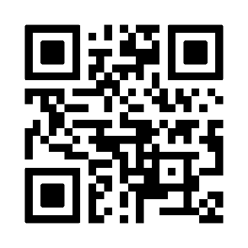

Responding to vent alarms
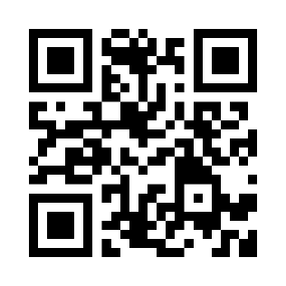
Resuscitation Bag

Video  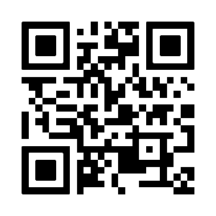 | PDF  